* **[How to create a Site Column](https://sharepoint.rackspace.com/Learning/Articles/Pages/SharePoint-2013--how-to-create-a-site-column.aspx)**

What is the difference between a site column and a list or library column? To put it simply, a site column can be used for maintaining structure throughout your lists and libraries.  If you were to create a column in a list or library, that column would only available in the one particular list or library in which it was created.  For example, if you have a Choice site column at your top-level site and want to apply this column to all of your subsites to keep consistency throughout, this is possible with a site column.

1. From your SharePoint site, in the upper right-hand corner click the **Site Settings Gear**.

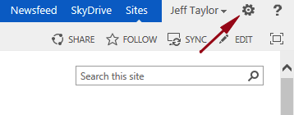

2. On the drop-down click **Site Settings**.

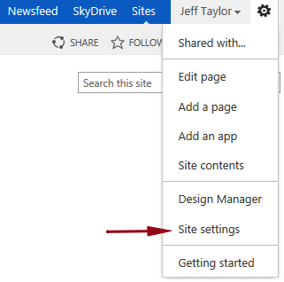

3. On the Site Settings page, under Web Designer Galleries, click **Site Columns**.

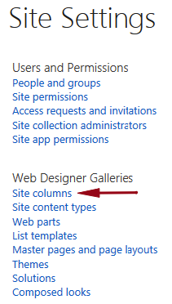

4. On the Site Columns page click **Create**.

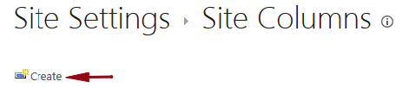

For the most part this will look similar to creating a normal list or library column.  You will notice a few additional column types available:

* Full HTML content with formatting and constraints for publishing
* Image with formatting and constraints for publishing
* Hyperlink with formatting and constraints for publishing
* Summary Links data
* Rich media data for publishing

5.     Enter the following information:

* 1. Column name: **Product Offering**
  2. The type of information in this column is: **Choice (menu to choose from)**
  3. Put this site column into: **Custom Columns**
  4. Description: **These are choices of our current product offerings**.
  5. Type each choice on a separate line:
     + **Beginner SharePoint 2010 Training**
     + **Beginner SharePoint 2013 Training**
     + **Advanced SharePoint 2010 Training**
     + **Advanced SharePoint 2013 Training**
     + **SharePoint Workflow Training**
  6. Default value: **(Make blank unless you have a choice you use often.)**

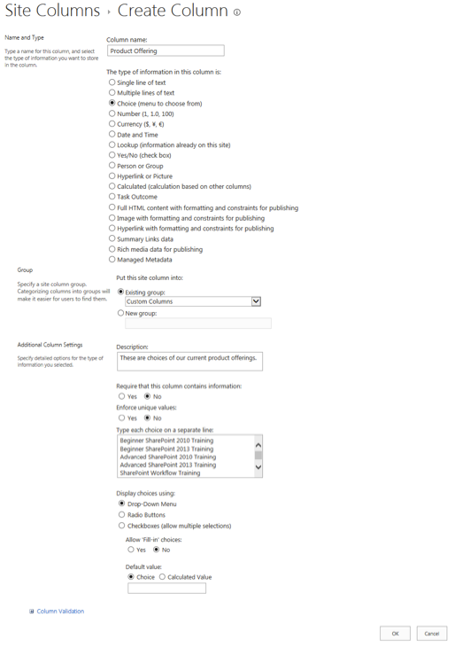

6. Review your settings and click **OK**.

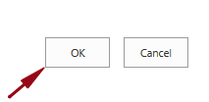

7. On the Site Columns page, if you look under the Custom Columns group you will see your new Site Column, in this example “**Product Offering**” has been created.

